**EXERCISE 5**

1. Write a shell script that takes a command line argument and reports on whether it is directory, a file, or something else.

**CODE**

if [ -f $1 ]

then

echo "It is ordinary file!!"

elif [ -d $1 ]

then

echo "It is a directory!!"

else

echo "Other file!!"

fi

**OUTPUT**



2) Write a shell script that computes the gross salary of a employee according  to the following rules :

i) if basic salary is < 1500 then HRA =10% of the basic and DA =90% of the basic.

ii) If basic salary is >=1500 then HRA =Rs500 and DA=98% of the basic.

**CODE**

read -p "Enter basic salary:" s

if [ $s -lt 1500 ]

then

echo "HRA :" $(( 10*s/100 ))

echo "DA :" $(( 90*s/100 ))

else

echo "HRA :"500

echo "DA :" $(( 98*s/100 ))

fi

**OUTPUT**

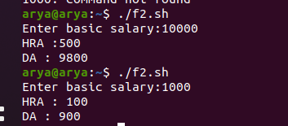

 3) Write a shell script that accepts two integers as its arguments and  computes the value of first number raised to the power of the second  number.

**CODE**

read -p "Enter first number:" a

read -p "Enter second number:" b

echo "Power:"$(( a**b ))

**OUTPUT**

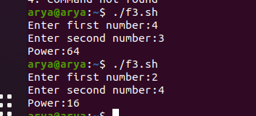

4) Write a shell script which receives two file names as arguments. It should  check whether the two file contents are same or not. If they are same then  second file should be deleted.

**CODE**

read -p "Enter the first file :" a

read -p "Enter the second file :" b

if cmp "$a" "$b"

then

echo "The contents of the two files are same!!"

rm -i $b

else

echo "The contents of the two files are different!!"

fi

**OUTPUT**

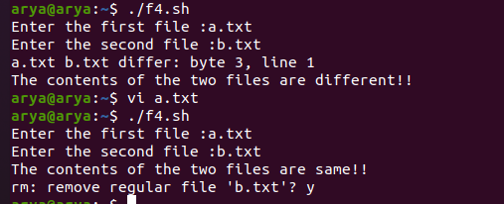

5) Write a shell script for Calculator

**CODE**

i=1

while [ $i -gt 0 ]

do

echo "1.Addition"

echo "2.Subtraction"

echo "3.Multiplication"

echo "4.Division"

echo "5.Power"

echo "6.Exit"

read -p "Enter a number:" a

read -p "Enter another number:" b

read -p "Enter choice:" ch

case $ch in

1)echo "sum is:" $(( a+b ))

;;

2)echo "difference is:" $(( a-b ))

;;

3)echo "product is:" $(( a*b ))

;;

4)echo "quotient is:" $(( a/b ))

;;

5)echo "power is:" $(( a**b ))

;;

6)exit

esac

done

**OUTPUT**

